David Vallecampo 991487504 – Activity 5 WIFI

Output 2:

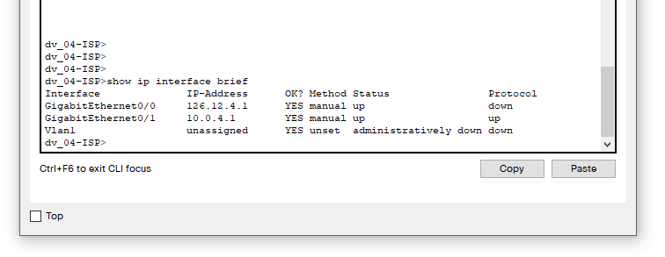

Public IP addresses:

Would be the IP address that is assigned to your router by the ISP.

Private IP addresses:

Is a hidden address that lies beyond the router, with which you devices and the router use to interact.

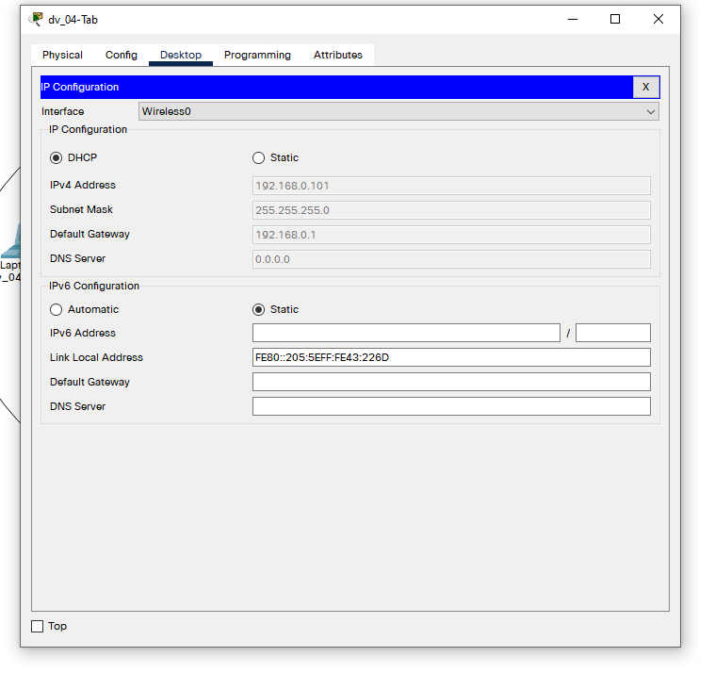

Output 3: Tablet IP address

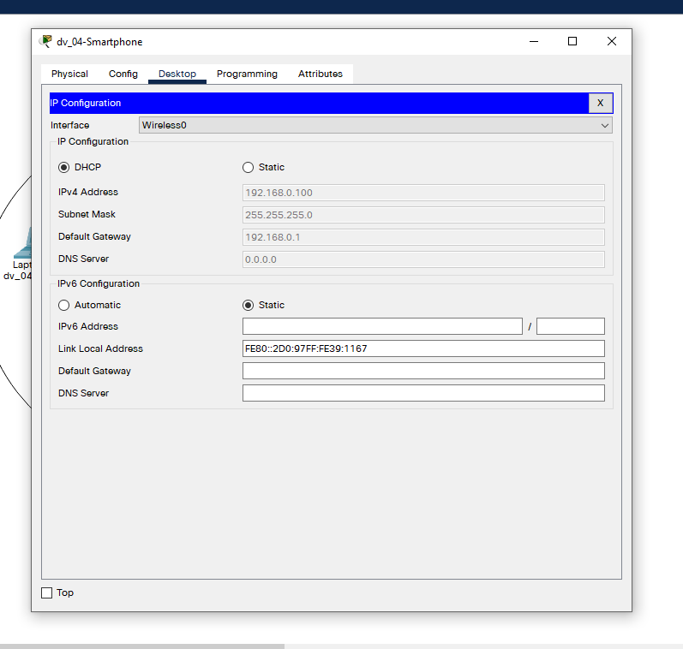

Output 4: Smartphone IP address

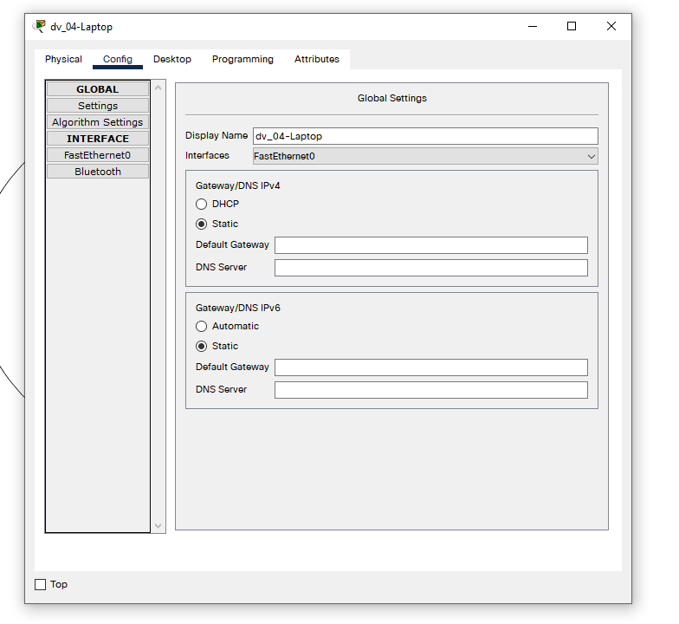

Output 5: Laptop has no wireless interface

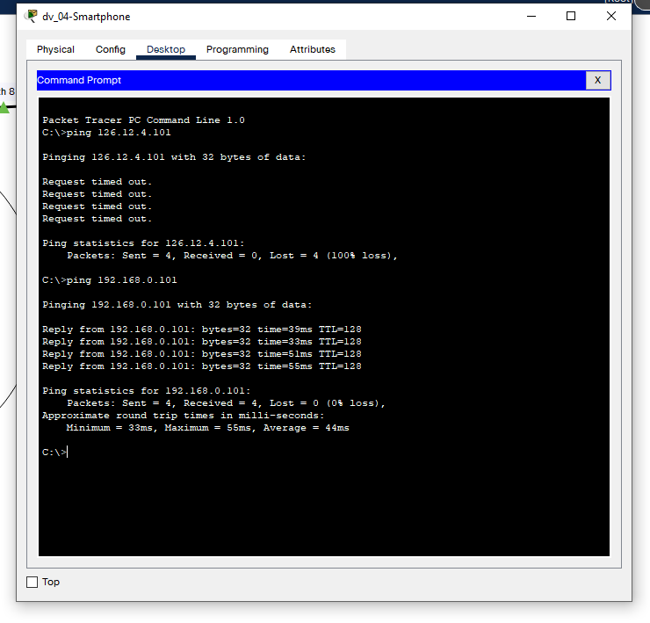

Output 6: Ping from Smartphone to Laptop

Both devices are easily able to communicate on the network between themselves

No ping from Laptop – Output 7: null as there is no wifi capability for my laptop